Project Design Phase
Solution Architecture

Date | 30 September 2026
Team ID
Project Name | SHOPEZ : E-commerce Application
Maximum Marks | 4 Marks

Solution Architecture:
Solution Architecture:
The solution architecture for the Stock Trading & Portfolio Management System defines how the frontend, backend, database, authentication, market-data services, and administrative functions work together to provide a secure simulated trading platform.
Its goals are:
• Provide a responsive React.js interface for exploring stocks, viewing market trends, and managing portfolios.
• Use Node.js and Express.js APIs to handle authentication, stock data, simulated buy/sell transactions, and portfolio operations.
• Store users, stocks, transactions, and portfolio information securely in MongoDB using Mongoose.
• Protect application resources using JWT authentication, bcrypt password hashing, CORS, and USER/ADMIN role-based access.
• Support market visualization through stock charts and enable administrators to monitor and moderate the platform.
Proposed Solution Architecture Diagram:
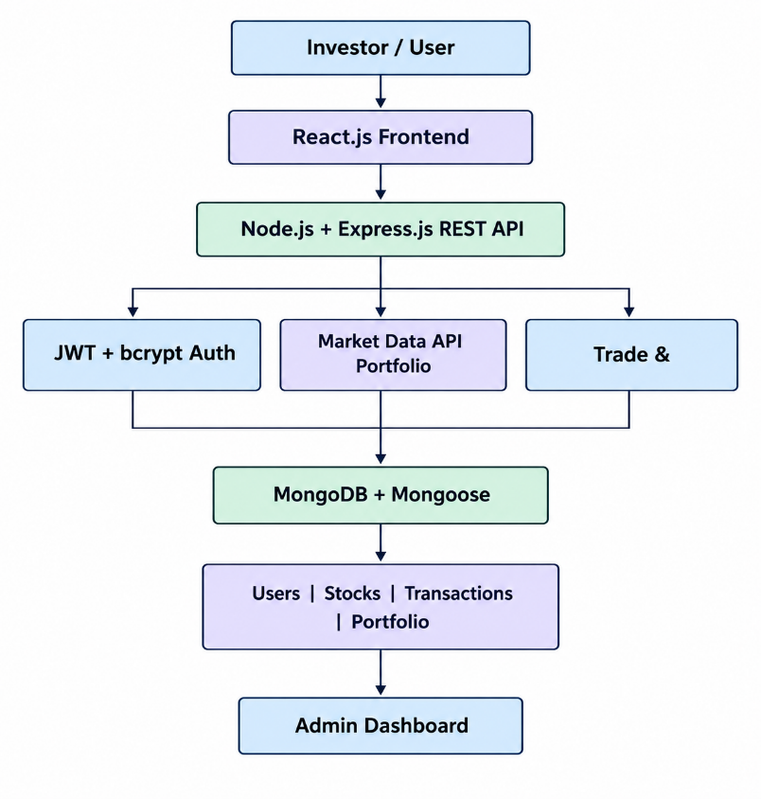
Architecture Component Description
Component | Description
React.js Frontend | Responsive interface for login, market overview, stock details, trading, portfolio tracking, and administration.
Axios / React Router | REST API communication and client-side navigation.
Node.js + Express.js | REST APIs, business logic, transaction processing, validation, error handling, and logging.
JWT + bcryptjs | Authentication, protected routes, and secure password hashing.
MongoDB + Mongoose | Stores Users, Stocks, Transactions, and Portfolio data.
External Stock API | Provides market stock information to the backend.
Chart.js / Recharts | Displays stock prices, historical trends, and portfolio data.
Admin Module | Protected dashboard for monitoring and moderation.
Architecture Flow
1. The user accesses the React.js frontend and registers or logs in.
2. Express.js validates credentials; bcryptjs protects passwords and successful authentication returns a JWT.
3. The frontend requests stock information through Axios and the Express REST API; market data may be retrieved from an external stock API.
4. A simulated buy/sell request is validated for user permissions, quantity, and available virtual balance.
5. Successful trades create transaction records and update portfolio holdings and virtual balance in MongoDB.
6. Portfolio pages retrieve holdings, transaction history, and profit/loss data and display them using React components and charts.
7. Administrators use protected admin routes to monitor and moderate platform activity.
Figure 1: Proposed solution architecture and data flow of the Stock Trading & Portfolio Management System
Reference: Solution Architecture template provided for the project design phase. fileciteturn3file0L2-L18

